**Introduction to Scientific Computing**

**CSCI 2150**

**Fall 2015**

**Points: 100**

**Assignment due: 10/5/2015**

Write a MATLAB code to do the following:

1. Approximate $\sqrt{9.1}and \sqrt{8.88}$ using linear approximation. Evaluate L(9.1) and L(8.88) for approximation.
2. In this case you will be required to plot the function f(x) = $\sqrt{x}$ and the two points L(9.1) and L(8.88).
3. Your output should look like this:

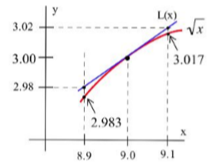

1. Find the root of $(e^{-x})*\left(x^{2}+5x+2\right)+1=0$ using the bisection method. Initial limits are 0 and -1
2. Here the range is -1 to 0. So you have to be careful with the selection of tolerance factor.
3. Your function should take 3 parameters as input: function f(x), a, b where a = -1 and b = 0 in this case.
4. Your output should look like this:

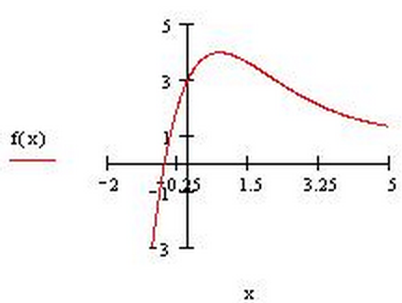

Instructions:

1. Write 2 different MATLAB files for the 2 questions. Name them *linearApprox()* and *bisection()* respectively
2. Label your graphs. Since these will be two different files, you do not have to subplot these in one figure. Plot them individually.

*******Bonus Question****** Additional 50 points if executed successfully.

**Bonus part is NOT mandatory. You can attempt it if time permits. Could be considered for partial credit.**

1. Write the above two programs in one single file and make the program menu driven.
2. The program should take user input for either performing the linear approximation or getting the root by the bisection method.
3. In this case you cannot give a hardcoded input. So even the input should be taken from the user.
4. Plot the two graphs as subplots.